***Hippity’s Hop***

***Game Design Document (GDD)***

***‘LET’S HOPPITY!!’*** – Hippity (Kyle O’Dell)

This page: Table of Contents and Team Member Listing

|  |  |  |
| --- | --- | --- |
| Table of Contents  [1 Game Overview](https://n-xovwktmtjsnaxyc2mwes2xu7pohqedmdm6zjw5q-2lu-script.googleusercontent.com/userCodeAppPanel)  [2 High Concept](https://n-xovwktmtjsnaxyc2mwes2xu7pohqedmdm6zjw5q-2lu-script.googleusercontent.com/userCodeAppPanel)  [3 Unique Selling Points](https://n-xovwktmtjsnaxyc2mwes2xu7pohqedmdm6zjw5q-2lu-script.googleusercontent.com/userCodeAppPanel)  [4 Platform Minimum Requirements](https://n-xovwktmtjsnaxyc2mwes2xu7pohqedmdm6zjw5q-2lu-script.googleusercontent.com/userCodeAppPanel)  [5 Competitors / Similar Titles](https://n-xovwktmtjsnaxyc2mwes2xu7pohqedmdm6zjw5q-2lu-script.googleusercontent.com/userCodeAppPanel)  [6 Synopsis](https://n-xovwktmtjsnaxyc2mwes2xu7pohqedmdm6zjw5q-2lu-script.googleusercontent.com/userCodeAppPanel)  [7 Game Objectives](https://n-xovwktmtjsnaxyc2mwes2xu7pohqedmdm6zjw5q-2lu-script.googleusercontent.com/userCodeAppPanel)  [8 Game Rules](https://n-xovwktmtjsnaxyc2mwes2xu7pohqedmdm6zjw5q-2lu-script.googleusercontent.com/userCodeAppPanel)  [9 Game Structure](https://n-xovwktmtjsnaxyc2mwes2xu7pohqedmdm6zjw5q-2lu-script.googleusercontent.com/userCodeAppPanel)  [10 Game Play](https://n-xovwktmtjsnaxyc2mwes2xu7pohqedmdm6zjw5q-2lu-script.googleusercontent.com/userCodeAppPanel)  [10.1 Game Controls](https://n-xovwktmtjsnaxyc2mwes2xu7pohqedmdm6zjw5q-2lu-script.googleusercontent.com/userCodeAppPanel)  [10.2 Game Camera](https://n-xovwktmtjsnaxyc2mwes2xu7pohqedmdm6zjw5q-2lu-script.googleusercontent.com/userCodeAppPanel)  [10.2.1 HUD](https://n-xovwktmtjsnaxyc2mwes2xu7pohqedmdm6zjw5q-2lu-script.googleusercontent.com/userCodeAppPanel)  [10.2.2 Maps](https://n-xovwktmtjsnaxyc2mwes2xu7pohqedmdm6zjw5q-2lu-script.googleusercontent.com/userCodeAppPanel)  [11 Players](https://n-xovwktmtjsnaxyc2mwes2xu7pohqedmdm6zjw5q-2lu-script.googleusercontent.com/userCodeAppPanel)  [11.1 Characters](https://n-xovwktmtjsnaxyc2mwes2xu7pohqedmdm6zjw5q-2lu-script.googleusercontent.com/userCodeAppPanel)  [11.2 Metrics](https://n-xovwktmtjsnaxyc2mwes2xu7pohqedmdm6zjw5q-2lu-script.googleusercontent.com/userCodeAppPanel)  [11.3 States](https://n-xovwktmtjsnaxyc2mwes2xu7pohqedmdm6zjw5q-2lu-script.googleusercontent.com/userCodeAppPanel)  [11.4 Weapons](https://n-xovwktmtjsnaxyc2mwes2xu7pohqedmdm6zjw5q-2lu-script.googleusercontent.com/userCodeAppPanel)  [12 Player Line-up](https://n-xovwktmtjsnaxyc2mwes2xu7pohqedmdm6zjw5q-2lu-script.googleusercontent.com/userCodeAppPanel)  [13 NPC](https://n-xovwktmtjsnaxyc2mwes2xu7pohqedmdm6zjw5q-2lu-script.googleusercontent.com/userCodeAppPanel)  [13.1 Enemies](https://n-xovwktmtjsnaxyc2mwes2xu7pohqedmdm6zjw5q-2lu-script.googleusercontent.com/userCodeAppPanel)  [13.1.1 Enemy States](https://n-xovwktmtjsnaxyc2mwes2xu7pohqedmdm6zjw5q-2lu-script.googleusercontent.com/userCodeAppPanel)  [13.1.2 Enemy Spawn Points](https://n-xovwktmtjsnaxyc2mwes2xu7pohqedmdm6zjw5q-2lu-script.googleusercontent.com/userCodeAppPanel)  [13.2 Allies / Companions](https://n-xovwktmtjsnaxyc2mwes2xu7pohqedmdm6zjw5q-2lu-script.googleusercontent.com/userCodeAppPanel)  [13.2.1 Ally States](https://n-xovwktmtjsnaxyc2mwes2xu7pohqedmdm6zjw5q-2lu-script.googleusercontent.com/userCodeAppPanel)  [13.2.2 Ally Spawn Points](https://n-xovwktmtjsnaxyc2mwes2xu7pohqedmdm6zjw5q-2lu-script.googleusercontent.com/userCodeAppPanel)  [14 Art](https://n-xovwktmtjsnaxyc2mwes2xu7pohqedmdm6zjw5q-2lu-script.googleusercontent.com/userCodeAppPanel)  [14.1 Setting](https://n-xovwktmtjsnaxyc2mwes2xu7pohqedmdm6zjw5q-2lu-script.googleusercontent.com/userCodeAppPanel)  [14.2 Level Design](https://n-xovwktmtjsnaxyc2mwes2xu7pohqedmdm6zjw5q-2lu-script.googleusercontent.com/userCodeAppPanel)  [14.3 Audio](https://n-xovwktmtjsnaxyc2mwes2xu7pohqedmdm6zjw5q-2lu-script.googleusercontent.com/userCodeAppPanel)  [15 Procedurally Generated Content](https://n-xovwktmtjsnaxyc2mwes2xu7pohqedmdm6zjw5q-2lu-script.googleusercontent.com/userCodeAppPanel)  [15.1 Environment](https://n-xovwktmtjsnaxyc2mwes2xu7pohqedmdm6zjw5q-2lu-script.googleusercontent.com/userCodeAppPanel)  [15.2 Levels](https://n-xovwktmtjsnaxyc2mwes2xu7pohqedmdm6zjw5q-2lu-script.googleusercontent.com/userCodeAppPanel)  [15.3 Artificial Intelligence NPC](https://n-xovwktmtjsnaxyc2mwes2xu7pohqedmdm6zjw5q-2lu-script.googleusercontent.com/userCodeAppPanel)  [15.4 Visual Arts](https://n-xovwktmtjsnaxyc2mwes2xu7pohqedmdm6zjw5q-2lu-script.googleusercontent.com/userCodeAppPanel)  [15.5 Audio](https://n-xovwktmtjsnaxyc2mwes2xu7pohqedmdm6zjw5q-2lu-script.googleusercontent.com/userCodeAppPanel)  [15.6 Minimum Viable Product (MPV)](https://n-xovwktmtjsnaxyc2mwes2xu7pohqedmdm6zjw5q-2lu-script.googleusercontent.com/userCodeAppPanel)  [16 Wish List](https://n-xovwktmtjsnaxyc2mwes2xu7pohqedmdm6zjw5q-2lu-script.googleusercontent.com/userCodeAppPanel)   |  | | --- | |  | | Game Development Team Members    PRODUCER  Kyle O’Dell    PRODUCTION MANAGER  Kyle O’Dell    PRODUCTION COORDINATOR  Kyle O’Dell  GAME DESIGNERS  Kyle O’Dell  SYSTEMS/IT COORDINATOR  Kyle O’Dell  PROGRAMMERS  Kyle O’Dell  TECHNICAL ARTISTS  Kyle O’Dell  AUDIO ENGINEERS  Kyle O’Dell  UX TESTERS  Kyle O’Dell |

|  |
| --- |
|  |

# 1 Game Overview

Title: Hippity’s Hop

Platform: PC Standalone

Genre: 3D Platformer / Adventure

Rating: (10+) ESRB

Target: Casual gamer (aging from 12 - 30)

Release date: May, 2020

Publisher: MSO Productions

Hippity’s Hop is a 3D platformer and adventure game where the Player has to help Hippity find his grandfathers lost orbs, requiring the player to overcome obstacles, survive enemies, and solve puzzles.

# 2 High Concept

Hippity’s Hop places the player initially in an expansive terrain where the player can explore to discover lost orbs. Along the terrain are small fast enemies who will attack the player, and the player must evade their attacks due to the lack of weapons.

# 3 Unique Selling Points

* Unique story
* Multiplatform across Windows/Linux/Mac OS

# 4 Platform Minimum Requirements

PC, MAC AND LINUX STANDALONE

Build for modern PC.

# 5 Competitors / Similar Titles

//TODO:

# 6 Synopsis

Landing in an unknown terrain, it’s up to you to explore and find out what is happening. Upon entering a house nearby, you meet Hippity, and unusual but happy, nice character who is asking you a favor to find his grandfathers lost orbs. He says they mean a lot to him. Go on an adventure to find his lost orbs, but also discover the truth about Hippity.

# 7 Game Objectives

Proceed through the various maps, surviving the attacks of Mini-Enemies, and try to find all of the orbs, puzzles, and fights.

# 8 Game Rules

Player has no means of fighting, must evade attacks and even sometimes use the environment to fight. Player must find certain number of orbs to proceed through certain areas and levels.

# 9 Game Structure

Main Menu 🡪 FirstLevel 🡪 Find Ten Orbs 🡪 SecondLevel 🡪 Complete Puzzle 🡪 FinalLevel 🡪 Beat Boss 🡪 Credits

If HP = 0 🡪 Gameover screen

# 10 Game Play

## 10.1 Game Controls

WASD – Move player

Space -- Jump

Shift(Hold while moving) -- Sprint

E – Speak, read, interact with objects

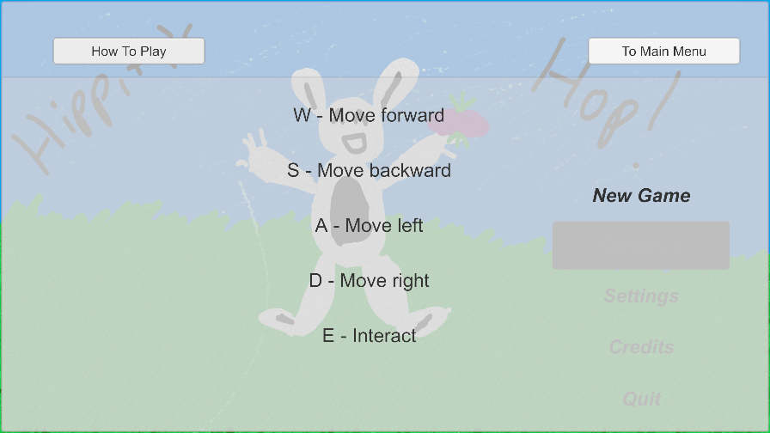

## 10.2 Game Camera

Camera focuses on players first person perspective.

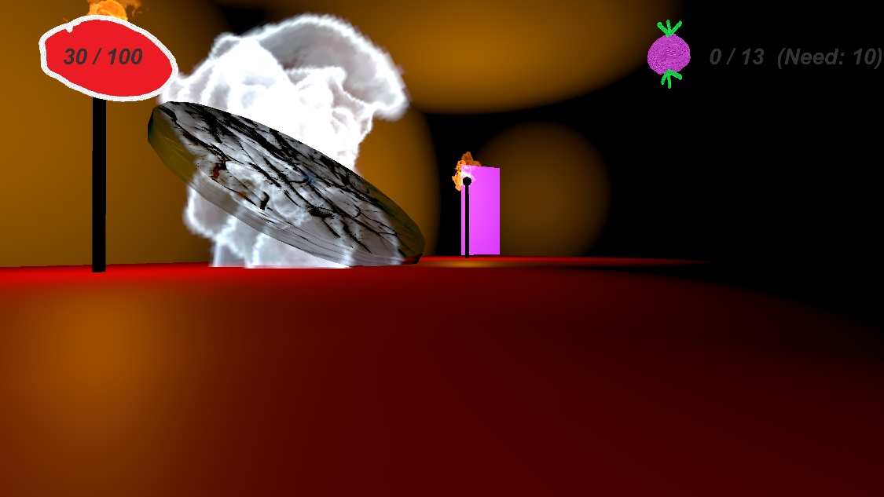

### 10.2.1 HUD

Player HP -- Informs player of remaining health

Inventory – Displays players orb count

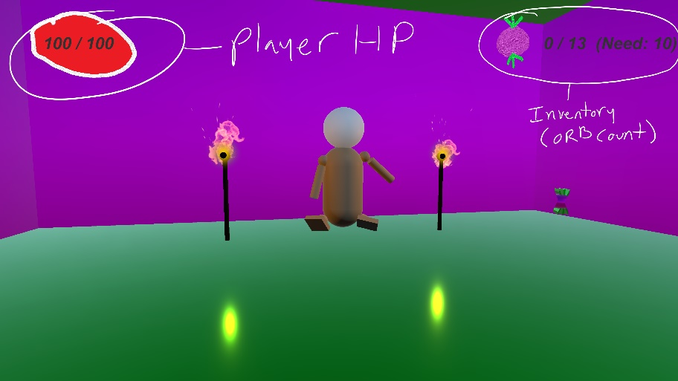

### 10.2.2 Maps

First Level

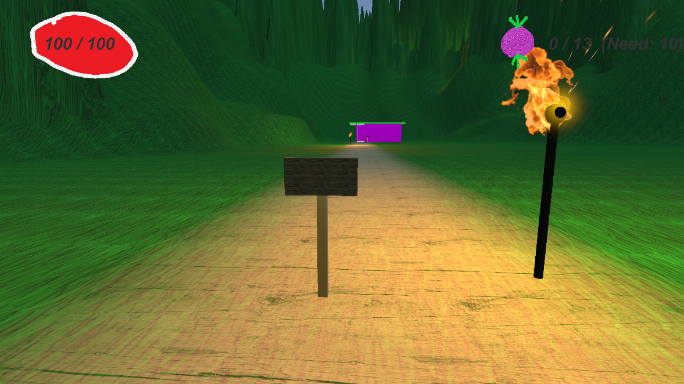

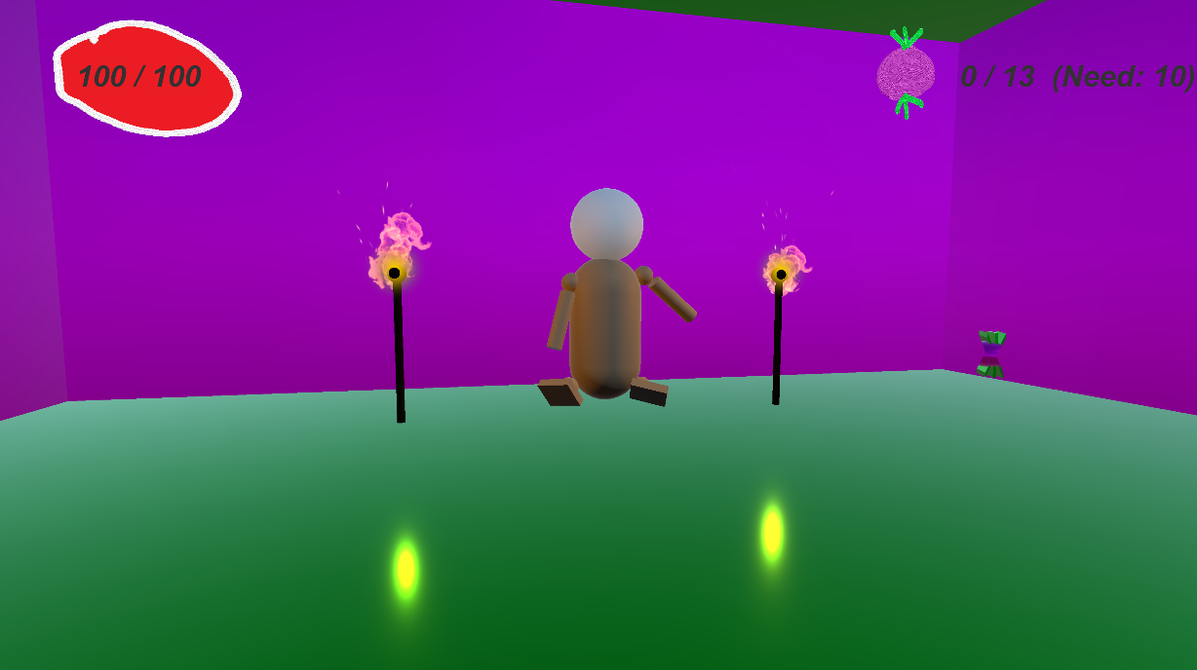

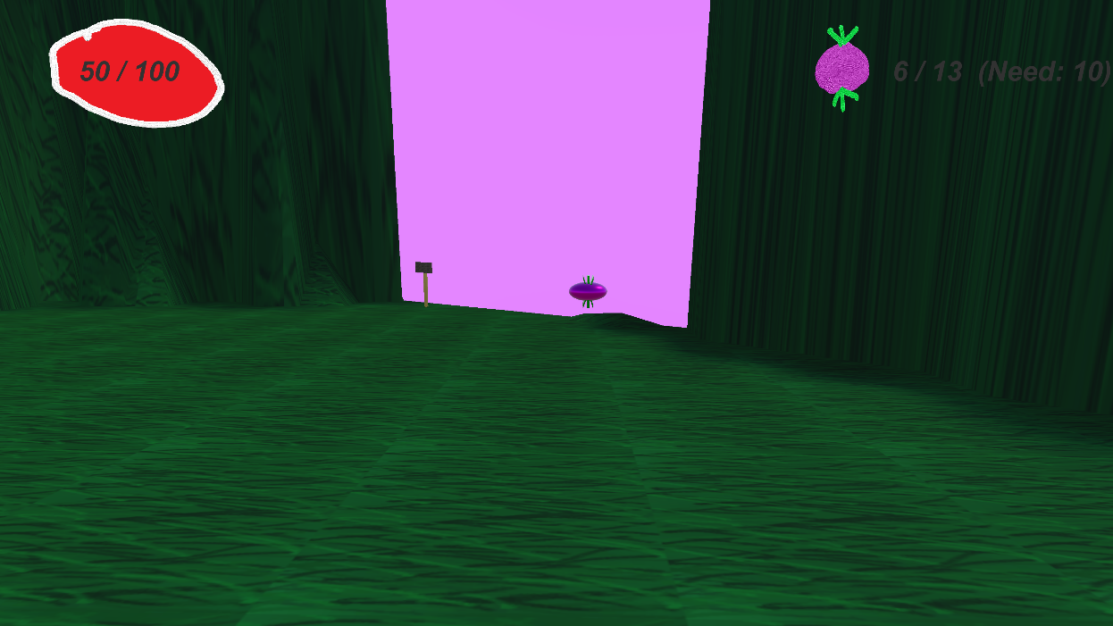

Second Level

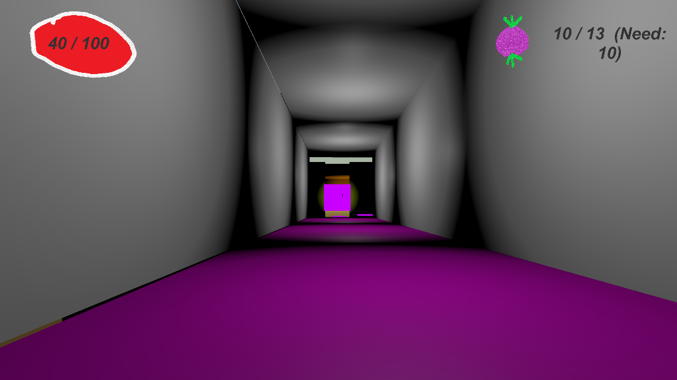

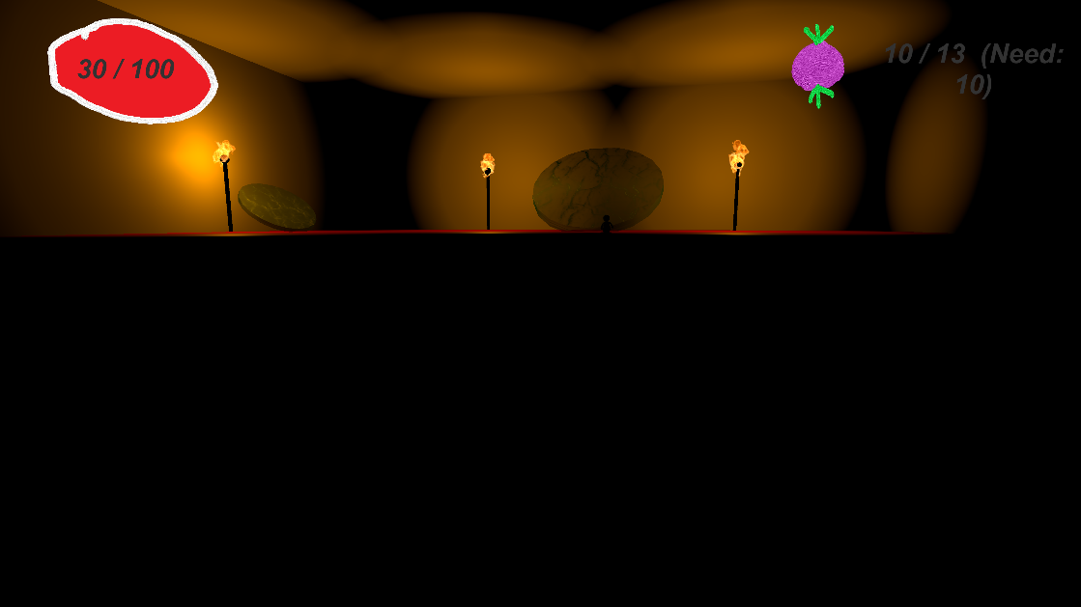

Third Level

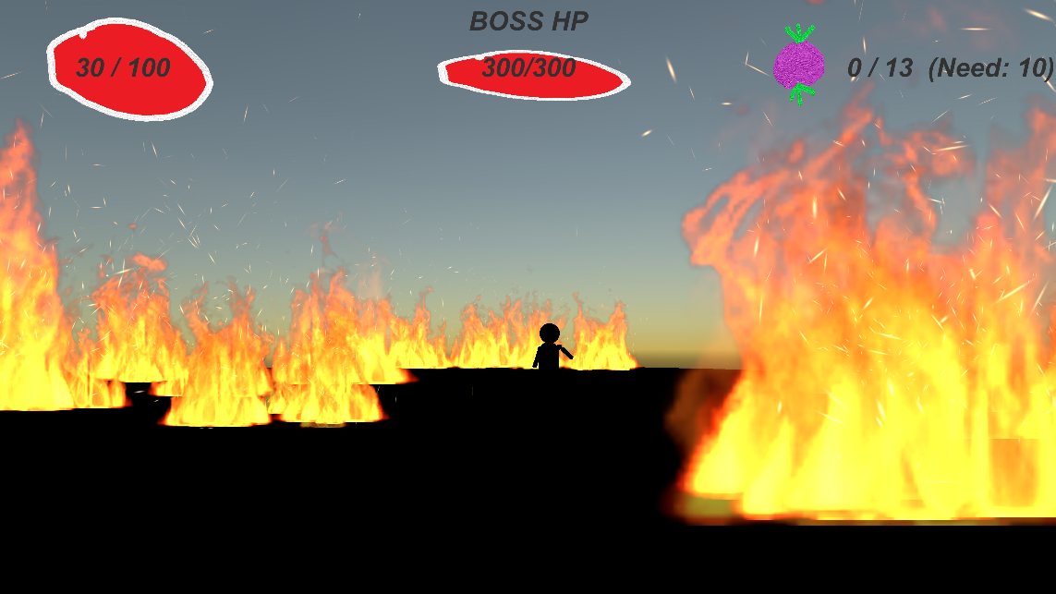

# 11 Players

## 11.1 Characters

The main character is you! This game is played from your own perspective.

## 11.2 Metrics

Player Metrics:

Speed: 13

Sprint Speed: 20

Max Health: 100

## 11.3 States

N/A

## 11.4 Weapons

The main character has no weapons.

# 12 Player Line-up

Hippity

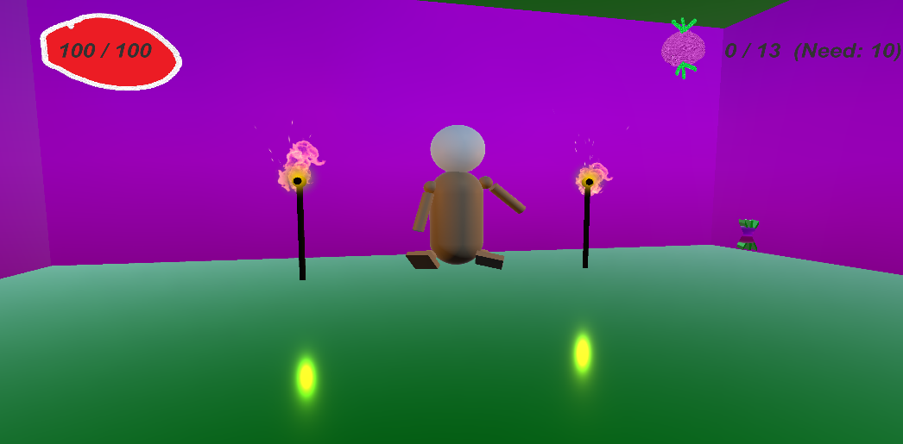

Mini-Enemies

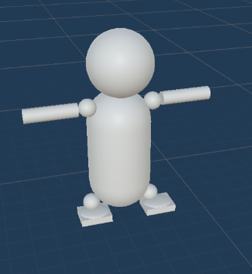

# 13 NPC

## 13.1 Enemies

Mini-Enemies

* HP = N/A
* Speed = 18
* Damage = 10
* Cool down = .1 seconds

Boss (Hippity)

* HP = 300
* Speed = 15
* Damage = 15
* Cool down = .1 seconds

### 13.1.1 Enemy States

Mini-Enemies – Sprinting fast, the little guys act sporadic, arms flying in every direction. They cannot die.

Hippity – Generally not aggressive, until the end. Hippity has a lot of dialog.

### 13.1.2 Enemy Spawn Points

Mini-Enemies spawn throughout the terrain at predetermined locations.

Hippity spawns as an enemy on the final stage.

## 13.2 Allies / Companions

### 13.2.1 Ally States

Hippity – Dancing poorly.

### 13.2.2 Ally Spawn Points

Hippity appears in his house in the first level, in the orb room in the second level, and gives his last dialog prior to becoming aggressive in the last level in the center of the field.

# 14 Art

## 14.1 Setting

The game takes place in a large terrain, lab, and fiery arena.

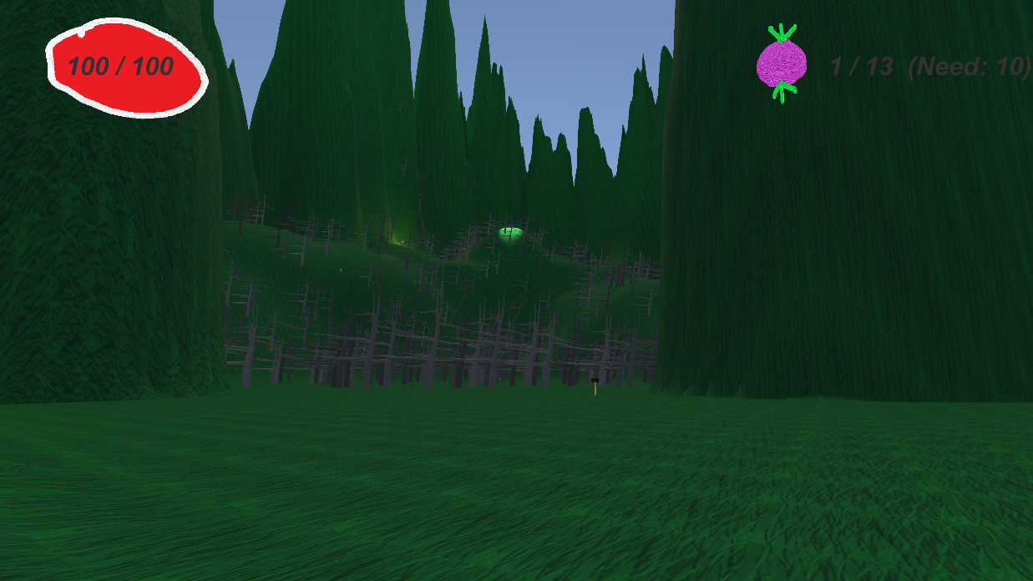

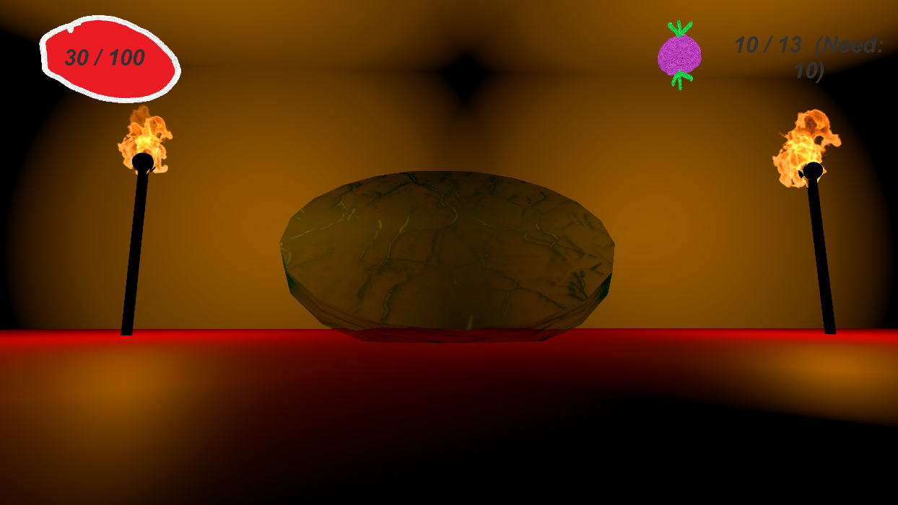

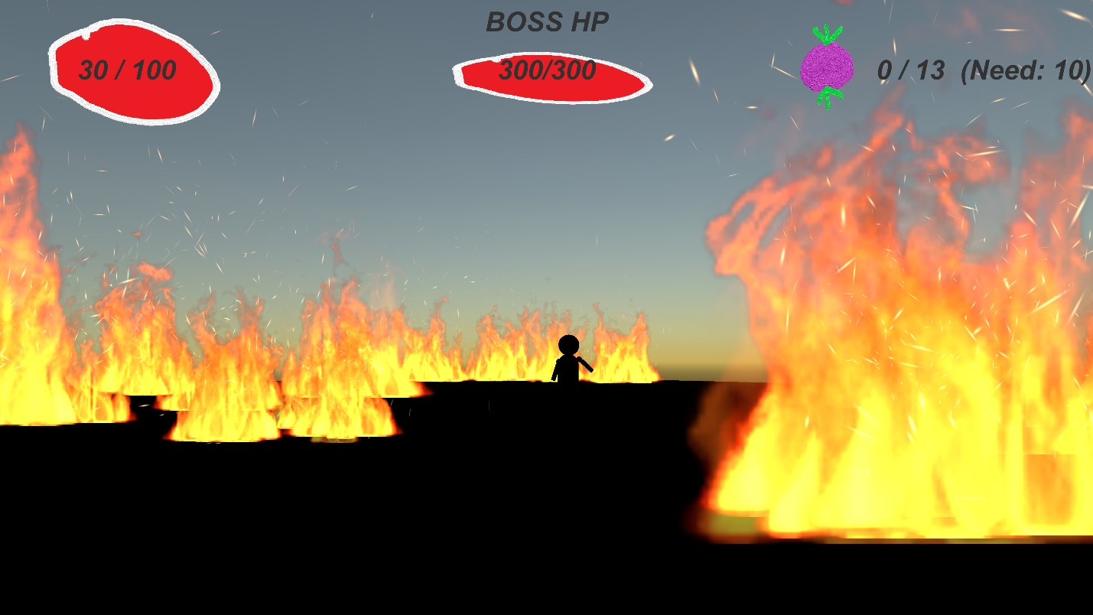

## 14.2 Level Design

The first level is a collector state, the player has to collect at least ten orbs while avoiding the attacks of mini-enemies.

The second level is a platform stage, where the player must jump to various points to complete a simple puzzle and avoid falling in a pit full of enemies.

The final level is just a boss fight where the player must use the environment to defeat the boss.

## 14.3 Audio

CreditsTrack – Music – Plays during credits and first level

3dintrotrack – Music – Plays in background of main menu

Level2 – Music – Plays in background of second level

FinalFight – Music – Plays in background of final level

FULL2-1 – FX – Plays when player walks near waterfall in first level

greenLightSound – FX – Plays when player turns on torches in second level

HealingSound – FX – Plays when orbs are picked up

Hit-sound – FX – Plays when player gets hit

BossDying – FX – Plays when final boss dies

# 15 Procedurally Generated Content

**N/A**

## 15.1 Environment

N/A

## 15.2 Levels

N/A

## 15.3 Artificial Intelligence NPC

N/A

## 15.4 Visual Arts

N/A

## 15.5 Audio

N/A

## 15.6 Minimum Viable Product (MPV)

* Built for the PC platform

# 16 Wish List

* More NPCs
* More levels
* Larger story
* Character development
* More items
* More weapons
* More abilities
* Skills

**Bibliography**

Kyle O’Dell

Department of Computer Science, San Diego State University

CS 583: 3D Game Programming

Professor Price

April 9, 2020

**References**

Thirslund, A. [Brackeys]. (2018, July 15). 2D Movement in Unity (Tutorial)[Video file]. Retrieved

from https://www.youtube.com/watch?v=dwcT-Dch0bA&t=220s

Thirslund, A. [Brackeys]. (2018, September 16). 2D Shooting in Unity (Tutorial)[Video file].

Retrieved from https://www.youtube.com/watch?v=wkKsl1Mfp5M

Thirslund, A. [Brackeys]. (2017, July 23). How to make a Dialogue System in Unity [Video file].

Retrieved from https://www.youtube.com/watch?v=_nRzoTzeyxU&t=593s

Thirslund, A. [Brackeys]. (2017, December 20). PAUSE MENU in Unity [Video file]. Retrieved

from https://www.youtube.com/watch?v=JivuXdrIHK0&t=458s

Thirslund, A. [Brackeys]. (2020, February 9). How to make a HEALTH BAR in Unity! [Video file].

Retrieved from https://www.youtube.com/watch?v=BLfNP4Sc_iA

**Original Assets**

Soundtrack:

Main Menu Theme – Written and produced by Kyle O’Dell

Gameover / credits theme – Written and produced by Kyle O’Dell

First level theme – Written and produced by Kyle O’Dell

Second level theme – Written and produced by Kyle O’Dell

Final level theme – Written and produced by Kyle O’Dell

Sounds:

Player death sounds – recorded by Kyle O’Dell

Player hit sounds – recorded by Kyle O’Dell

Enemy death sounds – recorded by Kyle O’Dell

Captain Cah’s voice – Kyle O’Dell

Jumping Sound – recorded by Kyle O’Dell

Green Light Activation sound – recorded by Kyle O’Dell

Running water sound – recorded by Kyle O’Dell

Gun shooting sound – recorded by Kyle O’Dell

Gaining health sound – recorded by Kyle O’Dell

Artwork:

Little Shammer character – Kyle O’Dell

Captain Cah character – Kyle O’Dell

Melee enemy – Kyle O’Dell

Exploding Enemy – Kyle O’Dell

Boss enemy – Kyle O’Dell

Hearts – Kyle O’Dell

Main Menu background – Kyle O’Dell

Tutorial level background – Kyle O’Dell

Ship Scene background – Kyle O’Dell

First level background – Kyle O’Dell

Second level background – Kyle O’Dell

Final level background – Kyle O’Dell

Red platforms – Kyle O’Dell

Flower platforms – Kyle O’Dell

Yellow platforms – Kyle O’Dell

Ship Platforms – Kyle O’Dell

Ground – Kyle O’Dell

House – Kyle O’Dell

Fireplace – Kyle O’Dell

Gun – Kyle O’Dell

Key – Kyle O’Dell

Keyhole – Kyle O’Dell

HUD inventory – Kyle O’Dell

Projectiles – Kyle O’Dell

**Play Testers**

Kyle McLain Kane

Maria Jose Molina Sanchez O’Dell

Michael Scott

Nathan Lehenbauer

Nhat Ho

Tim Backus

Jamshid Aziz

Norman Chau

Christopher Bradford

Michael Ruiz

Ivan Delgado